create table OlympicsData

(

Athlete STRING,

Age STRING,

Country STRING,

Year INT,

ClosingDate STRUCT<month:INT, day:INT, year:INT>,

Sport STRING,

GoldMedals INT,

SilverMedals INT,

BronzeMedals INT,

TotalMedals INT

)

ROW FORMAT DELIMITED FIELDS TERMINATED BY '\t'

collection items terminated by '-';

LOAD DATA LOCAL INPATH '/home/acadgild/hadoop/olympix_data.csv'

INTO TABLE raktim.OlympicsData;

SELECT Country,sum(TotalMedals) TotalMedals FROM raktim.OlympicsData where Sport='Swimming' group by Country;

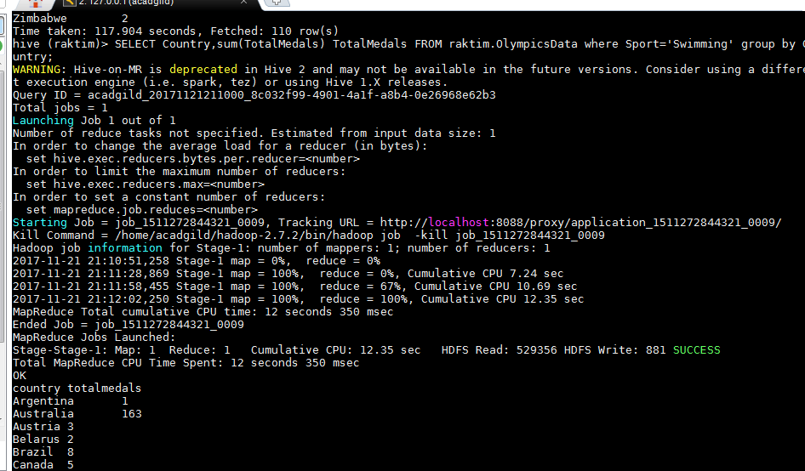

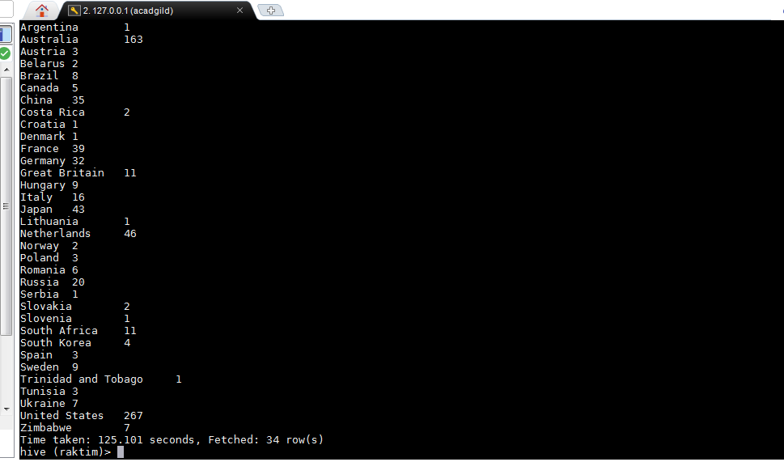

select Year, sum(TotalMedals) TotalMedals FROM OlympicsData where Country='India' group by Year;

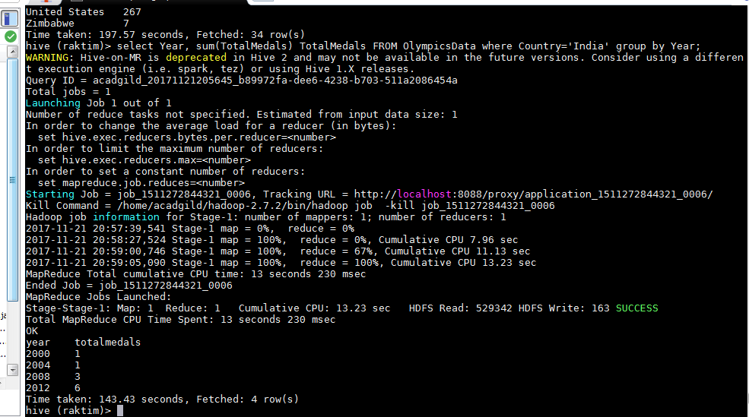

SELECT Country,sum(TotalMedals) TotalMedals FROM raktim.OlympicsData group by Country;

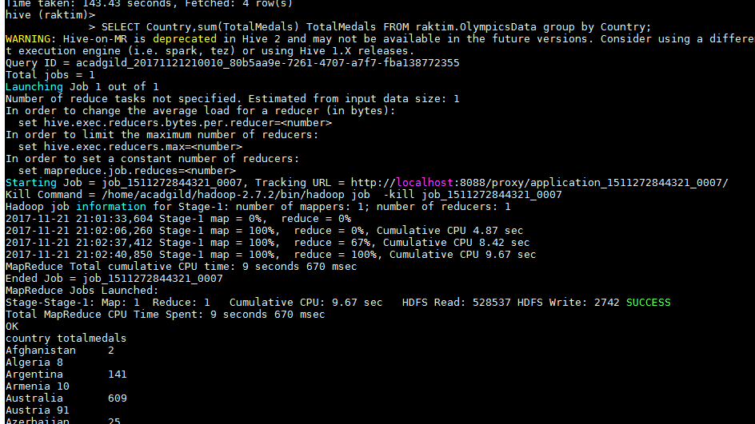

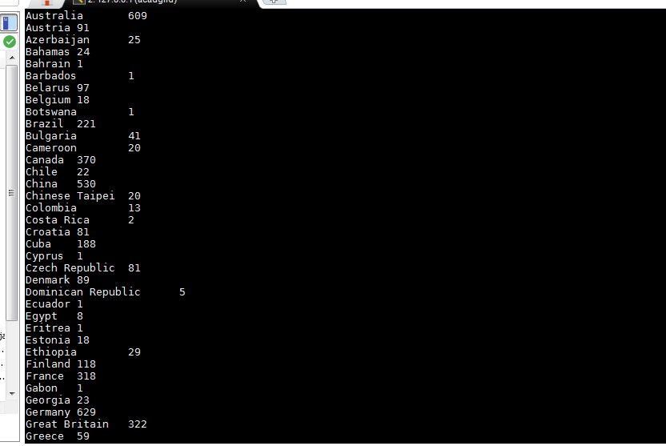

SELECT Country,sum(GoldMedals) GoldMedals FROM raktim.OlympicsData group by Country;

